Exercise 9
- List the minimum perks package.
SELECT MIN(perks) FROM `employee_data`;
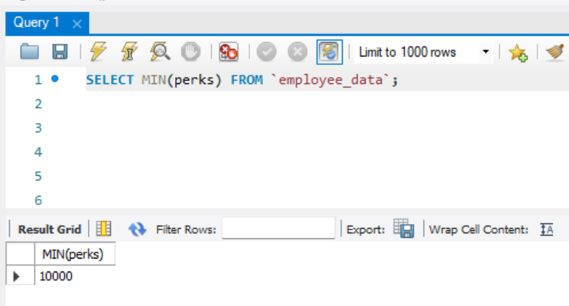
- List the maximum salary given to a “Programmer”.
SELECT MAX(salary) FROM `employee_data` WHERE title like "%programmer%";
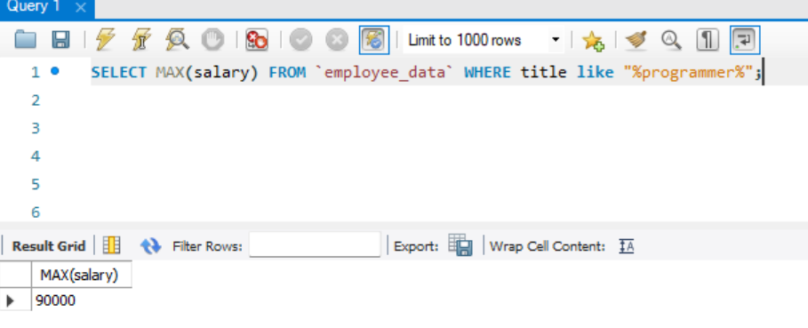
- Display the age of the oldest “Marketing Executive”.
SELECT MAX(age) FROM `employee_data` WHERE title like "Marketing Executive";
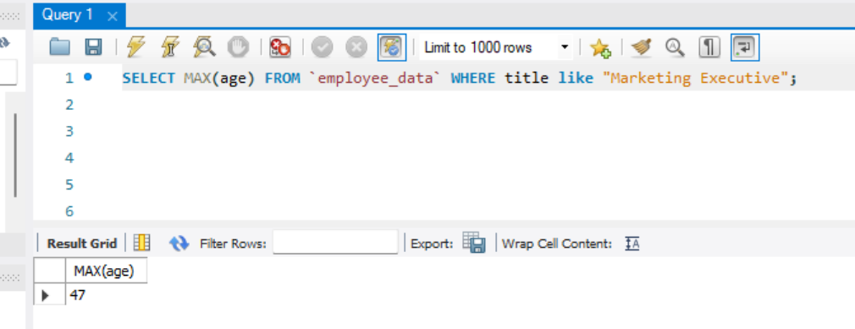
- (Tricky) Find the first and last names of the oldest employee.
SELECT f_name, l_name FROM `employee_data` WHERE age = (select max(age) from employee_data);
